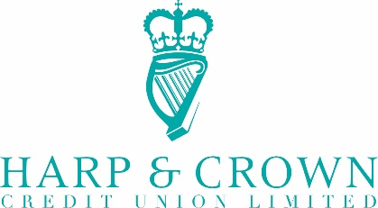

Notification to Members re Nominations for Elections

Dear Members

In accordance with Rule 47 of the approved rule book of Harp & Crown Credit Union Limited notice is hereby given that nominations for Directors should be made in writing, signed by a proposer and seconder, who shall be members of the credit union and also by the nominee to indicate consent, and should be sent by hand or by post so as to reach the registered office of the credit union by Friday 4th November 2022.

Should nominations exceed the number of positions available an election will take place at the AGM. There are five vacancies on the Board of Directors, three of these represent conclusions of terms, all of which have submitted nominations for re-election and two are members who have been co-opted to the Board during the last year and have also submitted nominations for election.

Kind regards

Fred Boyd, President

